ENSE 374 – Software Engineering Management

BookZilla

Alvin John Tolentino (200433749)

Quing Rosete (200449566)

Taiwo Akinwale (200430975)

**Table of Contents 1**

**Introduction.............................................................................................................................................. 2**

**2 Design Problem ...................................................................................................................................... 3**

**2.1 Problem Definition .............................................................................................................................. 3**

**2.2 Design Requirements .......................................................................................................................... 3**

**2.2.1 Functions .......................................................................................................................................... 3**

**2.2.2 Objectives........................................................................................................................................... 3**

**2.2.3 Constraints ........................................................................................................................................ 3**

**3 Solution.................................................................................................................................................... 4**

**3.1 Solution 1.............................................................................................................................................. 4**

**3.2 Solution 2.............................................................................................................................................. 4**

**3.3 Final Solution....................................................................................................................................... 4**

**3.3.1 Components...................................................................................................................................... 5**

**3.3.2 Features............................................................................................................................................. 5**

**3.3.4 Limitations ....................................................................................................................................... 5**

**4 Team Work............................................................................................................................................. 6**

**6 Gantt Chart.............................................................................................................................................7**

**6 Conclusion and Future Work............................................................................................................ 8-9**

**1 Introduction**

In the digital age, reading enthusiasts and book clubs require a unified platform to manage reading lists, schedule meetings, and engage in discussions about books. There is a lack of platforms that provide readers with the opportunity to portray and share their experiences with books. Furthermore, existing platforms often lack specific features for in-depth book club management. The project aims to create an online platform, like IMDb, but primarily focused on books to address this need.

**1.1 Purpose**

This report serves as documentation of the proposed BookZilla platform. It provides information about the goal and the benefits for both readers and the reading community at large.

**1.2 Scope**

The scope of this report encompasses a detailed examination of the design problem at hand, the requirements identified, and the potential solutions considered. It provides a roadmap for the subsequent sections, offering insights into the decision-making process and the considerations that informed the final proposed solution.

**1.3 Rationale**

The goal for this business initiative comes from the idea that existing platforms fall short in catering to the needs of readers. By creating a dedicated space, we aim to enhance literary engagement, facilitate community building, and provide a platform for the passionate exchange of ideas between book enthusiasts.

**1.4 Overview of Subsequent Sections**

Following this introduction, the report unfolds as follows:

* Section 2 delves into the specifics of the design problem, articulating the requirements and constraints identified during the analysis.
* Section 3 presents potential solutions considered during the design process, culminating in the final proposed solution.
* Section 4 sheds light on the collaborative efforts of the team during project meetings, providing insights into the decision-making process.
* Section 5 outlines the key aspects of project management, including timelines, resource allocation, and potential risks.
* Section 6 concludes the report by summarizing key findings, emphasizing the business benefits, and suggesting potential avenues for future development.

**2. Design Problem**

**2.1 Problem Definition**

In the ever-expanding digital realm, there exists a distinct lack of a dedicated platform for reading enthusiasts and book clubs to connect, organize, and engage in meaningful discussions. Current online spaces, such as amazon and fail to cater specifically to the unique needs of this demographic, lacking features essential for effective book club management and comprehensive literary engagement. The absence of such a platform hinders the ability of readers to share experiences, discuss their favorite books, and discover new literary works in a centralized and focused environment.

**2.2 Design Requirements**

**2.2.1 Functions**

The design project must encompass the following key functions to effectively address the identified problem:

* **Book Organization:** Enable users to create and manage personalized reading lists, categorizing books based on genres, themes, or personal preferences.
* **Discussion Forum:** Provide a dedicated space for users to engage in discussions about books, fostering a community-driven environment for sharing insights, opinions, and recommendations.

**2.2.2 Objectives**

The design project aims to achieve the following objectives:

* **Enhanced Community Building:** Foster a vibrant and active community of readers who can connect, interact, and share their passion for the novels they have read.
* **Improved Literary Engagement:** Cultivate a space where users can delve into in-depth discussions, discover new books/genres, and enhance their overall literary experience.
* **User Satisfaction:** Ensure that users find value and satisfaction in the platform through intuitive design, relevant features, and a seamless user experience.

**2.2.3 Constraints**

The design project operates within the following binary constraints:

* **Compatibility:** The platform must be compatible with a range of browsers to ensure widespread accessibility.
* **Data Security:** Ensure robust data security measures to protect user information and maintain the confidentiality of user’s information.

**3. Solution**

**3.1 Option 1: Perform the Project (Book Club/Reading Organizer)**

*Description:* The first option involves the development and launch of the Book Club/Reading Organizer platform called “BookZilla”. This solution includes features such as book organization discussion forums, and a server addressed to provide security and a base for the platform. It addresses the identified problem by providing a dedicated space for readers, enhancing literary engagement in the digital era.

**3.2 Option 2: Do Nothing**

*Description:* The second option involves continuing without creating the platform, resulting in a missed opportunity to provide a community for book enthusiasts.

*Reasons for Not Selecting:* Option 2 misses the chance to meet the needs of the book-loving community. This also provides no merit to both developers and future customers.

**3.3 Final Solution**

*Description:* The final solution is a developing "BookZilla”. It includes advanced functions such as book organization, discussion forums, and a server addressed to provide security and a base for the platform. This solution ensures compatibility, data security, and regulatory compliance.

*3.3.1 Components*

**Block Diagram (Fig. 1):**

* **User Interface (UI):** Enables user interaction and navigation.
* **Database:** Stores user data, book information, and discussion threads.
* **Discussion Forum:** Provides a space for users to engage in book-related discussions.

*3.3.2 Features*

|  |  |
| --- | --- |
| **Feature** | **Description** |
| Book Organization | Users can create and manage personalized reading lists. |
| Discussion Forum | Provides a dedicated space for users to engage in discussions. |
| User Profiles | Includes features such as bookshelves/favorites. |

3.3.2 Limitations

While the selected option is a simple solution, it may face potential glitches due to the limited resources and knowledge the developers have. Furthermore, there I no guarantee that the website’s feature will stay relevant compared to the ever-growing number of updates competitors have. To prevent this, developers have to continuously learn new ways to program and provide a steady flow of updates to stay relevant compared to other book websites.

**4 Teamwork**

Since this is a group project, there must be a fair distribution of tasks among the members. To this end, groups must hold meetings to discuss the distribution of tasks and to keep track of the project progress.

To keep on track, we provided a date for the group to meet every week. The meetings consisted of a meeting agenda, project report, and a division of tasks that needed to be done the following week. To keep track on which person is assigned certain tasks, we used a Gant chart and provided a meeting minutes file which contains what was done in specific weeks and what is needed to be done the next week. We also provided a project report, which contains the progress of the previous week. All these files can be accessed through our GitHub.

**5 Gantt Chart**

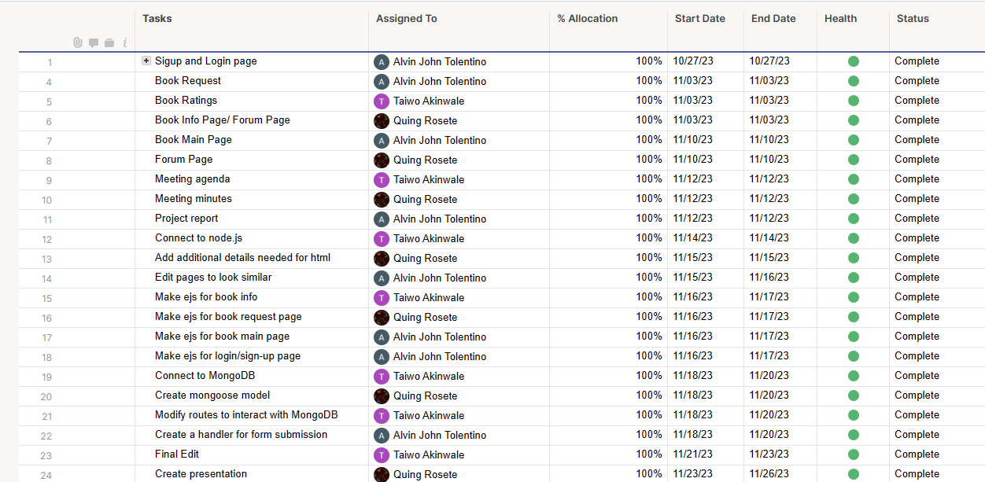

**6 Conclusion and Future Work**

**6.1 Summary of Achievements**

In conclusion, the implementation of Option 1, "Perform the Project (Book Club/Reading Organizer)," has resulted in the creation of a robust and comprehensive platform called “BookZilla”. The design successfully addressed the identified design functions and objectives, meeting the needs of readers and book clubs while adhering to the specified constraints.

**Achieved Design Functions:**

- **Book Organization**: Users can create and manage personalized reading lists.

- **Discussion Forum**: Provides a dedicated space for users to engage in discussions.

Achieved Design Objectives:

- **Enhanced Community Building**: Fostering a vibrant and active community of readers.

- **Improved Literary Engagement**: Cultivating a space for in-depth discussions and discovering new books.

- **User Satisfaction**: Ensuring users find value and satisfaction through an intuitive design and seamless user experience.

**Satisfying Constraints:**

- **Compatibility**: The platform is accessible across a range of browsers.

- **Data Security**: Robust measures are in place to protect user information and maintain confidentiality.

- **Scalability**: The design is scalable to accommodate a growing user base without compromising performance.

- **Regulatory Compliance**: The platform adheres to relevant legal and regulatory standards governing online platforms.

**6.2 Recommendations for Future Design Improvements**

While the current design has successfully addressed the identified needs and constraints, acknowledging its limitations and shortcomings is essential for continuous improvement. Future designs should improve with further updates and maintenance. Some future updates example are:

**Continuous Security Monitoring and Updates:**

Nowadays, database outbreaks are not out of the ordinary. Implementing the latest security protocols will fortify the system against outbreaks and other risks thaat may emerge.

**Personalization and Community Dynamics:**

To improve user engagement, future iterations could explore more advanced personalization features such as providing a way to message other users privately and adding other user’s reading list as your own. Improving community dynamics involves tailoring recommendations based on user preferences and community members.

**Integration with External Platforms:**

Consideration should be given to potential integrations with external platforms or services that complement BookZilla(like local libraries), enhancing its overall utility and user experience.

In conclusion, the current design sets a solid foundation for a dedicated space catering to the needs of readers and book clubs. By addressing the identified design functions, objectives, and constraints, the platform creates an enriched literary community. The recommendations for future improvements aim to ensure the continued evolution and success of the Book Club/Reading Organizer platform.